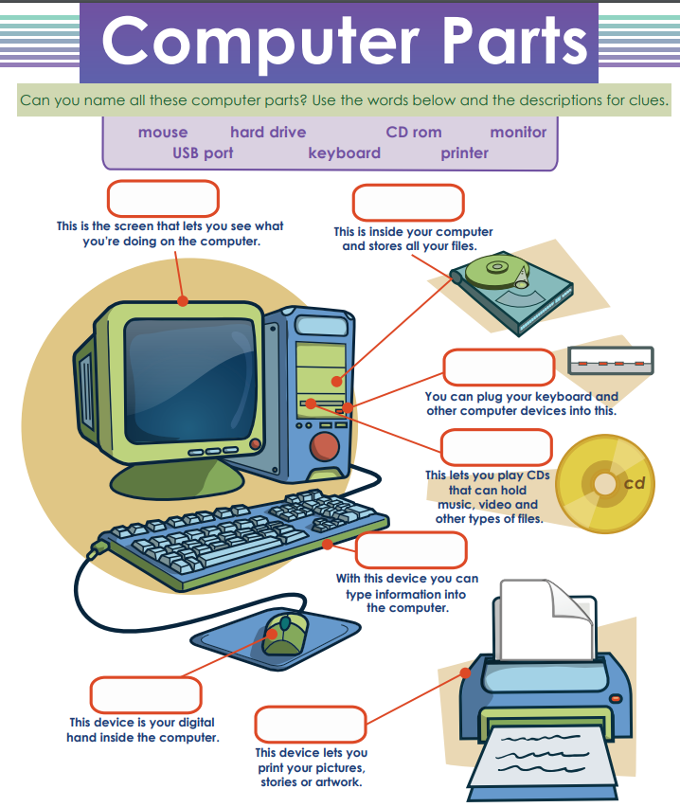

2- Find the following words. Colour each box. Each Word with a different colour
KEYBOARD
MOUSE
PRINTER
HARD DRIVE
COMPUTER
MONITOR

B | V | N | M | K | L | P | W | J | H
R | T | S | U | N | M | P | H | Q | W
Y | H | S | D | Y | M | Z | A | X | C
K | K | E | Y | B | O | A | R | D | B
Q | W | R | T | Y | U | P | D | S | D
G | H | T | Y | M | S | R | V | C | F
P | R | I | N | T | E | R | D | T | R
R | M | O | N | I | T | O | R | Y | M
Z | X | C | V | B | N | M | I | Q | W
Ñ | L | K | J | H | G | F | V | Q | W
Y | C | O | M | P | U | T | E | R | Z

